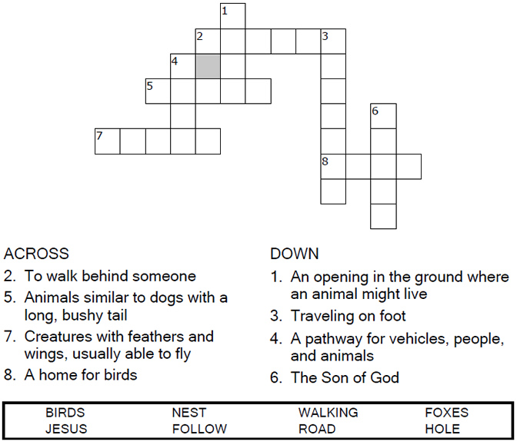

Copyright © Sermons4Kids, Inc.
May be reproduced for Ministry Use

Children’s Worship Bulletin

Bible Story 519

Hold on to Jesus
Luke 9:56-62



St Lawrence, Denton
27th June 2010

Luke 9:56-62 (New International Version)
⁵⁶and^{[a]} they went to another village.

The Cost of Following Jesus
⁵⁷As they were walking along the road, a man said to him, "I will follow you wherever you go."
⁵⁸Jesus replied, "Foxes have holes and birds of the air have nests, but the Son of Man has no place to lay his head."
⁵⁹He said to another man, "Follow me."
But the man replied, "Lord, first let me go and bury my father."
⁶⁰Jesus said to him, "Let the dead bury their own dead, but you go and proclaim the kingdom of God."
⁶¹ Still another said, "I will follow you, Lord; but first let me go back and say good-by to my family."
⁶²Jesus replied, "No one who puts his hand to the plow and looks back is fit for service in the kingdom of God."

Hold on to Jesus

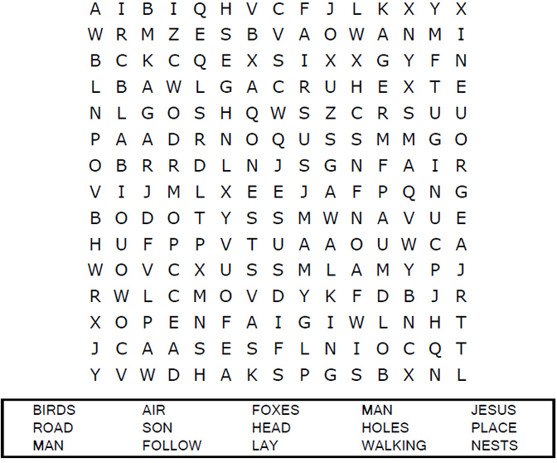

Connect the dots to complete the picture.
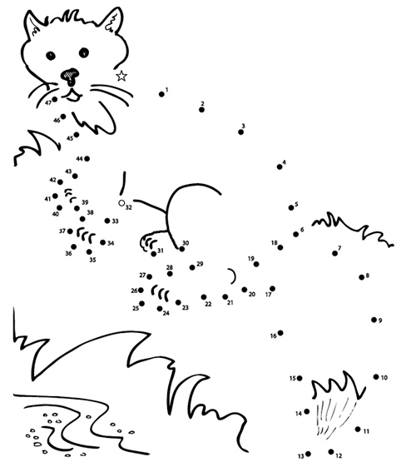

Jesus replied, "Foxes have holes and birds of the air have nests,
but the Son of Man has no place to lay his head."
Luke 9:58 (NIV)
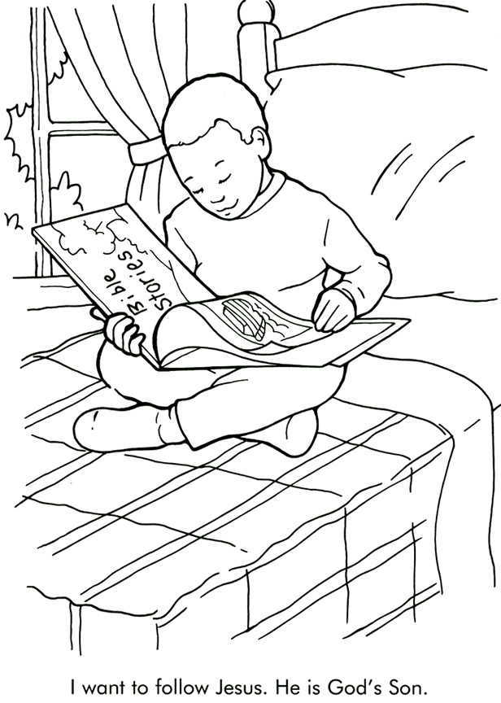

From Thru-the-Bible Coloring Pages for Ages 4-8. © 1986,1988 Standard Publishing.
Used by permission. Reproducible Coloring Books may be purchased from
Standard Publishing, www.standardpub.com, 1-800-543-1301.

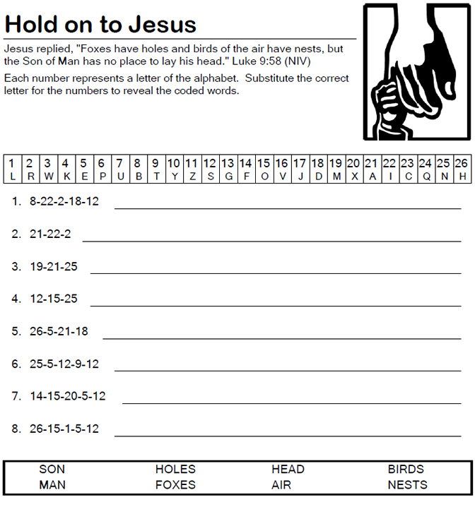

I wish I could protect you
from the worries of this life.
but if there's one thing I could tell you
it's no matter what you do
hold to Jesus, He's holding onto you.

Heavenly Father, we thank you for sending your Son to save us and to be our guide through life. We are holding on to Jesus. Amen.

He’s got the whole world in his hands
He’s got the whole world in his hands
He’s got the whole wide world in his hands
He’s got the whole world in his hands

He’s got the tiny little baby in his hands
He’s got the tiny little baby in his hands
He’s got the tiny little baby in his hands
He’s got the whole world in his hands

He’s got you and me brother in his hands
He’s got you and me sister in hands
He’s got you and me brother in his hands
He’s got the whole world in his hands

