Children’s Worship Bulletin

Bible Story 519

Hold on to Jesus
Luke 10:1-11



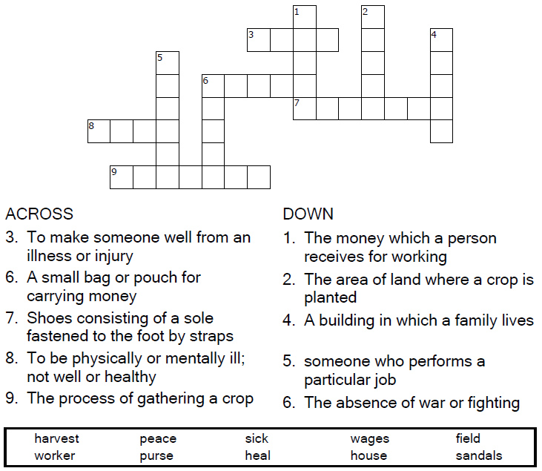

Copyright © Sermons4Kids, Inc.
May be reproduced for Ministry Use

St Lawrence, Denton
4th July 2010

Luke 10:1-11 (New International Version)

Jesus Sends Out the Seventytwo
¹After this the Lord appointed seventy-two^{[a]} others and sent them two by two ahead of him to every town and place where he was about to go. ²He told them, "The harvest is plentiful, but the workers are few. Ask the Lord of the harvest, therefore, to send out workers into his harvest field. ³Go! I am sending you out like lambs among wolves. ⁴Do not take a purse or bag or sandals; and do not greet anyone on the road.
⁵"When you enter a house, first say, 'Peace to this house.' ⁶If a man of peace is there, your peace will rest on him; if not, it will return to you. ⁷Stay in that house, eating and drinking whatever they give you, for the worker deserves his wages. Do not move around from house to house.
⁸"When you enter a town and are welcomed, eat what is set before you. ⁹Heal the sick who are there and tell them, 'The kingdom of God is near you.' ¹⁰But when you enter a town and are not welcomed, go into its streets and say, ¹¹'Even the dust of your town that sticks to our feet we wipe off against you. Yet be sure of this: The kingdom of God is near.'
Footnotes:
- Luke 10:1 Some manuscripts seventy; also in verse 17



It All Depends on Jesus

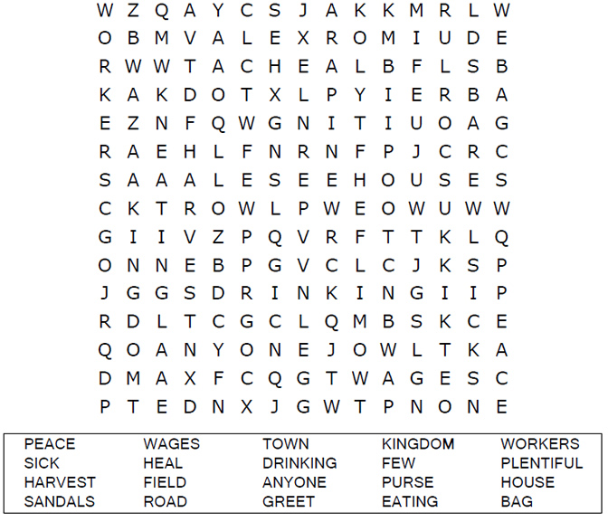

Each number represents a letter of the alphabet. Substitute
correct letter for the numbers to reveal the coded words.

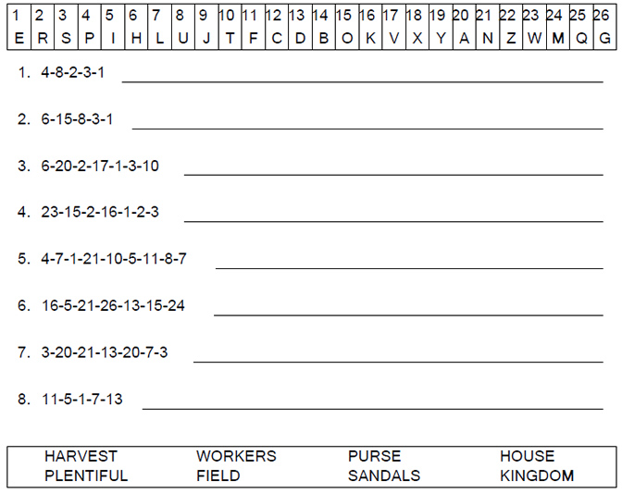



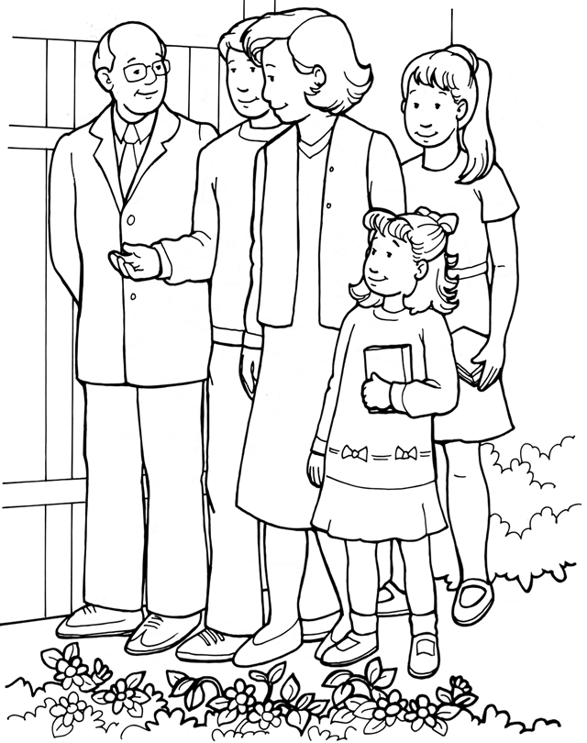
The church tells everyone Jesus’ Good News.

From Thru-the-Bible Coloring Pages for Ages 4-8. © 1986,1988 Standard Publishing.
Used by permission. Reproducible Coloring Books may be purchased from
Standard Publishing, www.standardpub.com, 1-800-543-1301.

Dear Jesus, may we be ready and willing to go when you say, "Go!" and leave the results up to you. Amen

Lord of life, you are Lord of young and old.
We thank you for old people.
They have so much to share with us:
Help us to be ready to listen.
They have had so many years to learn about your world:
Help us to be ready to learn from their advice.
They have met and known and loved so many people:
Help us to understand when they feel neglected by the young.
They have been part of events which we can only read about:
Help us to understand when they feel left out of today’s world.
Thankyou, Lord, for their gifts to us of knowledge, experience and love. Amen.

We have a gospel to proclaim,
Goodnews for men in all the earth;
The gospel of a saviour’s name:
We sing His glory, tell His worth.

Tell of His birth at Bethlehem,
Not in a royal house or hall
But in a stable dark and dim:
The Word made flesh, a light for all.

Tell of His death at Calvary,
Hated by those He came to save;
In lonely suffering on the cross
For all He loved His life He gave.

Tell of that glorious Easter morn:
Empty the tomb, for He was free;
He broke the power of death and hell
That we might share His victory.

Tell of His reign at God’s right hand,
By all creation glorified;
He sends His spirit on Hs church
To live for Him, the Lamb who died.

Now we rejoice to name Him king:
Jesus is Lord of all the earth;
This gospel-message we proclaim:
We sing His glory, tell His worth.

