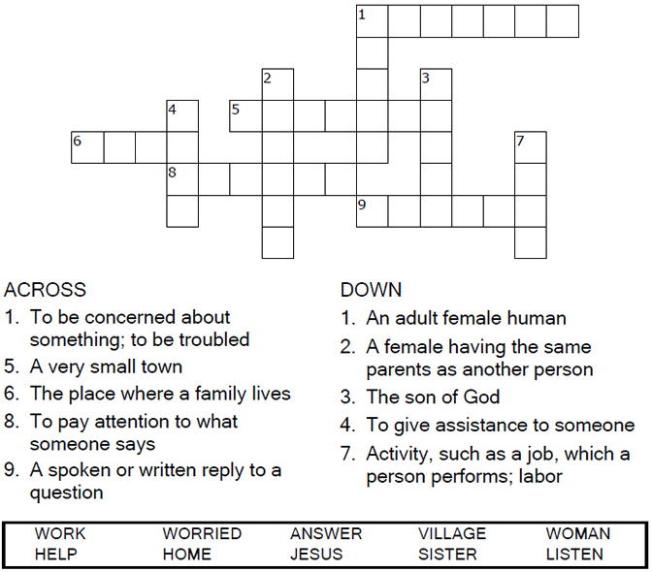

Copyright © Sermons4Kids, Inc.
May be reproduced for Ministry Use

Children’s Worship Bulletin

Bible Story 520

The Most Important Thing
Luke 10:38-42

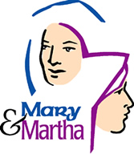

St Lawrence, Denton
18th July 2010

Luke 10:38-42 (New International Version)

At the Home of Martha and Mary
³⁸As Jesus and his disciples were on their way, he came to a village where a woman named Martha opened her home to him. ³⁹She had a sister called Mary, who sat at the Lord's feet listening to what he said. ⁴⁰But Martha was distracted by all the preparations that had to be made. She came to him and asked, "Lord, don't you care that my sister has left me to do the work by myself? Tell her to help me!"
⁴¹"Martha, Martha," the Lord answered, "you are worried and upset about many things, ⁴²but only one thing is needed.^{[a]} Mary has chosen what is better, and it will not be taken away from her."
Footnotes:
- Luke 10:42 Some manuscripts but few things are needed—or only one

Dear Jesus, help us to remember that you are the most important thing in our lives. Don't let us get so busy with other things that we forget to spend time with you. Amen.

The Most Important Thing

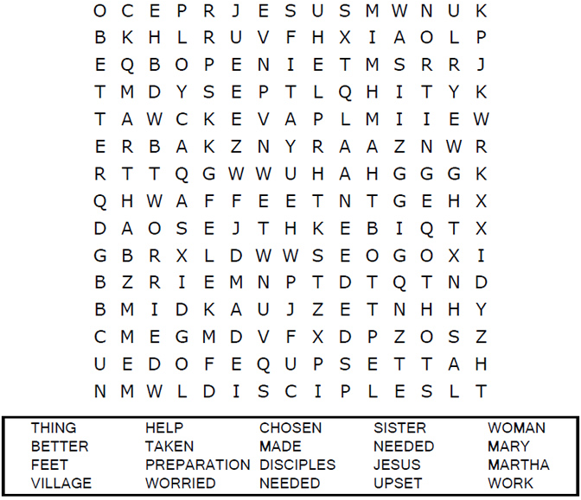



Each number represents a letter of the alphabet. Substitute
the correct letter for the numbers to reveal the coded words.
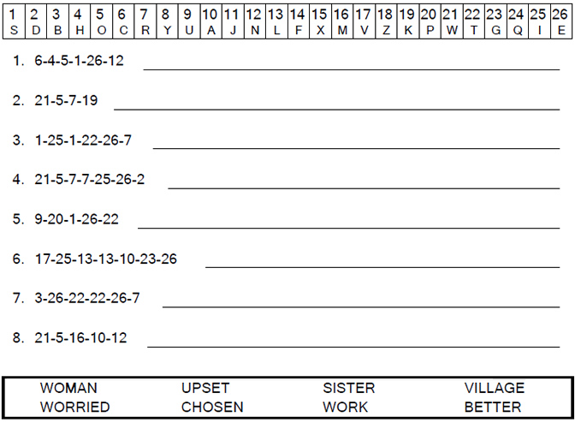


MEMORY VERSE:
"Give unto the LORD the glory due to His name; worship the LORD in the beauty of holiness." PSALM 29:2

TRUE OR FALSE:
1. "...He entered a certain village; and a certain woman named Martha welcomed Him into her
house." LUKE 10:38

TRUE OR FALSE
2. "And she had a sister called Mary, who also sat at Jesus' feet and heard His word." LUKE 10:39

FILL IN THE BLANK:
3. "But Martha was distracted with ___________ serving..." LUKE 10:40

TRUE OR FALSE:
4. "...and she approached Him and said, 'Lord, do You not care that my sister has left me to serve
alone?' " LUKE 10:40

FILL IN THE BLANK:
5. "...Therefore tell her to ___________ me." LUKE 10:40

TRUE OR FALSE:
6. And Jesus answered and said to her, "Martha, Martha, you are never worried or troubled."
LUKE 10:41

TRUE OR FALSE
7. "...But one thing is needed, and Mary has chosen that good part, which will not be taken away
from her." LUKE 10:42

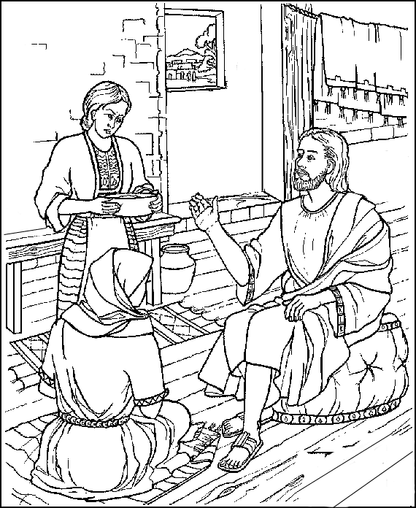

Jesus visits in the home of Mary and Martha.
Copyright © ABDA ACTS Art & Publishing
Used by permission.

